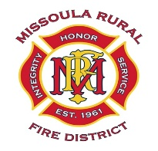
MISSOULA RURAL FIRE DISTRICT
BOARD OF TRUSTEES
NOTICE OF SPECIAL PUBLIC MEETING AND AGENDA

DATE: Thursday, June 25, 2026
TIME: 5:15 P.M.
PLACE: Station #1, 2521 South Avenue West, Missoula
________________________________________________________________________________

CALL TO ORDER
ROLL CALL
PUBLIC COMMENT (on any public matter that is not on the agenda and that is within the jurisdiction of the Board)
- Discussion and Decision on Board of Trustee Officer Elections.
- Discussion and Decision on Appointment of Acting Fire Chief.
- Discussion and Decision on Direction to Acting Fire Chief Regarding Review of Notice to District of Retirement Policy.
- Discussion and Decision on Fire Chief Recruitment Prothman Contract.
- Discussion and Decision on District Collective Bargaining Negotiating Team.
- Discussion and Decision on the Montana Department of Commerce METAP Contract.
ADJOURNMENT

