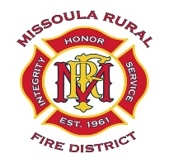
MISSOULA RURAL FIRE DISTRICT
BOARD OF TRUSTEES
NOTICE OF PUBLIC MEETING AND AGENDA

DATE: Monday, March 23, 2026
TIME: 4:00 P.M.
PLACE: Station #1, 2521 South Avenue West, Missoula
________________________________________________________________________________

CALL TO ORDER
ROLL CALL
PUBLIC COMMENT (on any public matter that is not on the agenda and that is within the jurisdiction of the Board)

1. Approval of Minutes for Regular Board Meeting held on February 10, 2026.

2. Discussion and Decision on Approval of January and February 2026 Claims.

January Claims $ 18,401.42
February Claims $332,869.45
Total Claims $351,270.87

3. Communications/Correspondence.

4. Trustee Reports.

5. Fire Chief and Staff Reports.

6. Discussion and Decision on Adoption of Retirement Plan Agreements for 457(b) and 401(a) Plans.

7. Discussion and Decision on Resolution #2026-03 Sale of Surplus Equipment.

8. Discussion and Decision on Resolution #2026-04 Adoption of the Patient Information Privacy and Confidentiality Policy.

9. Discussion and Decision on Approval of Accredited Agency Letter of Agreement.

ADJOURNMENT

