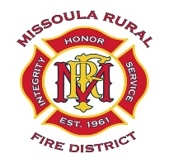
MISSOULA RURAL FIRE DISTRICT
BOARD OF TRUSTEES
NOTICE OF PUBLIC MEETING AND AGENDA

DATE: Tuesday, May 12, 2026
TIME: 4:00 P.M.
PLACE: Station #1, 2521 South Avenue West, Missoula
________________________________________________________________________________

CALL TO ORDER
ROLL CALL
PUBLIC COMMENT (on any public matter that is not on the agenda and that is within the jurisdiction of the Board)

1. Approval of Minutes for Regular Board Meeting held on April 14, 2026.

2. Discussion and Decision on Approval of March and April 2026 Claims.

March Claims $ 3,498.25
April Claims $211,629.42
Total Claims $215,127.67

3. Communications/Correspondence.

4. Trustee Reports.

5. Fire Chief and Staff Reports.

ADJOURNMENT

